**T. Y. B. Tech (Electrical and Computer Engineering)**

**Trimester: V Subject: Microcontroller and Applications**

**Name: Shreerang Mhatre Class: TY**

**Roll No: 52 Batch: A3**

**Experiment No: 07**

**Name of the Experiment:** Generation of PWM using C8051F340 to control speed of DC motor

**Performed on: 28/11/2023**

**Marks**

**Teacher’s Signature with date**

**Submitted on: 07/12/2023**



**Aim:** Write C program to generation PWM using C8051F340 to control speed of DC motor

**Apparatus:** EPBF340 board, DSO, DSO probes, DC motor

**Theory:**

**DC Motors:** A direct current (DC) motor is widely used device that translate electrical pulses into mechanical movement. In the DC motor we have only + and _ leads. Connecting them to a DC voltage source moves the motor in one direction . By reversing the polarity, the DC motor will move in the opposite direction.

Unidirectional control:

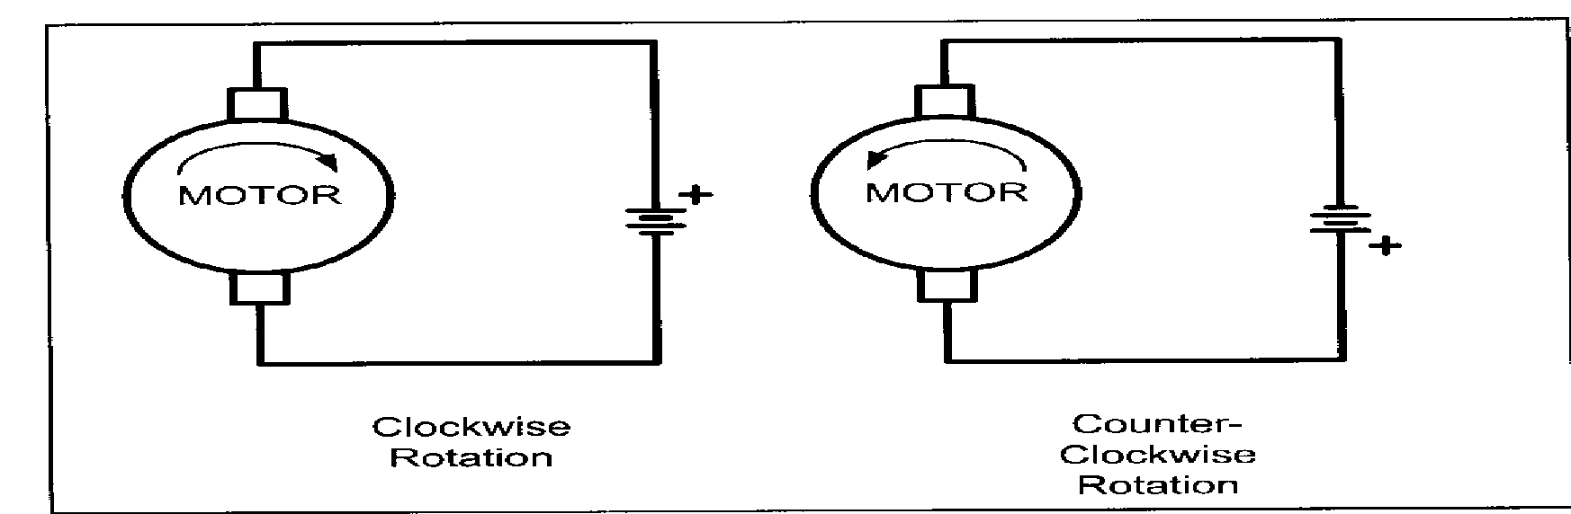

*Figure 7.1: Unidirectional control of DC motor*

**Pulse Width Modulation (PWM):**

The speed of motor depends on the three factors: i) load, ii) voltage, and iii) current. For a given fixed load we can maintain the steady speed by using a method called pulse width modulation (PWM). By changing (modulating) the width of the pulse applied to DC motor we can increase or decrease the amount of power provided to the motor , thereby increasing or decreasing the motor speed. Notice that although the voltage has a fixed amplitude, it has a variable duty cycle.

**PWM generation in C8051F340:**

The Programmable Counter Array (PCA0) provides enhanced timer functionality. The PCA consists of a dedicated 16-bit counter/timer and five 16-bit capture/compare modules. Each module can be used independently to generate a pulse width modulated (PWM) output on its associated CEXn pin. The frequency of the output is dependent on the timebase for the PCA counter/timer. The duty cycle of the PWM output signal is varied using the module's PCA0CPLn capture/compare register.

**Interfacing Diagram:**

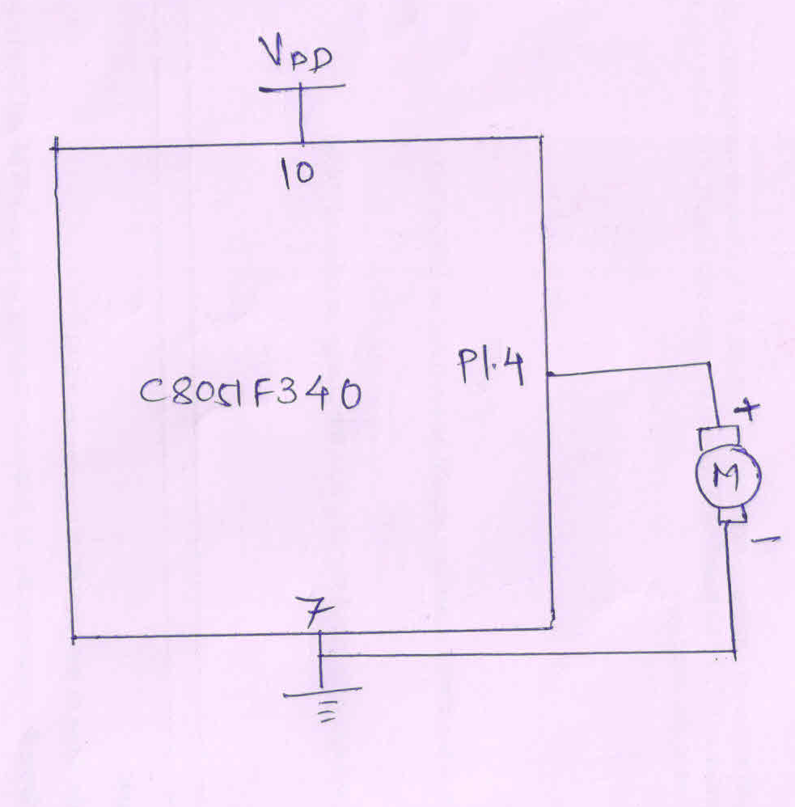

*Figure 7.2 Interfacing Diagram of DC motor with C8051F340*

**Calculations of duty cycle:** *DutyCycle = (*256-*PCA*0*CPHn)/256*

**Hardware Connections:** Output is available on Port pin P1.4. Observe waveform at pin no. 5 of PL3 connector of EPBF340 board with respect to ground on DSO/CRO. After this, connect DC motor between the same pin.

**Program:** Attach printout of the tested code.

**Calculations:**

**Find the value to be loaded in PCA0L for generating the PWM waveform of following frequencies and duty cycle: Consider System clock = 12 MHz**

|  |  |  |
| --- | --- | --- |
| **Desired Frequency and Duty cycle** | **PCA0L** | **PCA0CPH0** |
| 60KHz - 50% |  |  |
| 100KHz - 25% |  |  |
| 140KHz - 75% |  |  |

**Result:**

The duty cycle of the PWM waveform should be observed on DSO/CRO.

OR

DC Motor should run with speed varying w.r.t the change in value of PWM.

**Conclusion:**

**--------------------------------------------------------------------------------------------------------------------------------------------------------------------------------------------------------------------------------**

**Study Question:**

1. Define duty cycle.
2. Write the steps to program PCA to generate PWM
3. Write down the equations for the frequency and duty cycle of PWM in C8051F340

**Code for PWM using C8051F340:**

// Exp - 7 Generation of PWM using C8051F340 to control speed of DC motor

/*

Name: Shreerang Mhatre

Rollno: 52

Batch: A3

Class: TY

*/

#include "c8051f340.h"

#define SYSCLK 3000000

void main(){

    PCA0L=0x10;

    OSCICN=0x83;

    CLKSEL=0x00;

    XBR1=0x41;

    P2MDOUT=0x08;

    P0SKIP=0xff;

    P1SKIP=0xff;

    P2SKIP=0x07;

    while(1){

        PCA0MD=0x02;

        PCA0CPM0=0x42;

        PCA0CPH0=(256-(256*0.75));

        CR=1;

    }

}

**Output:**

